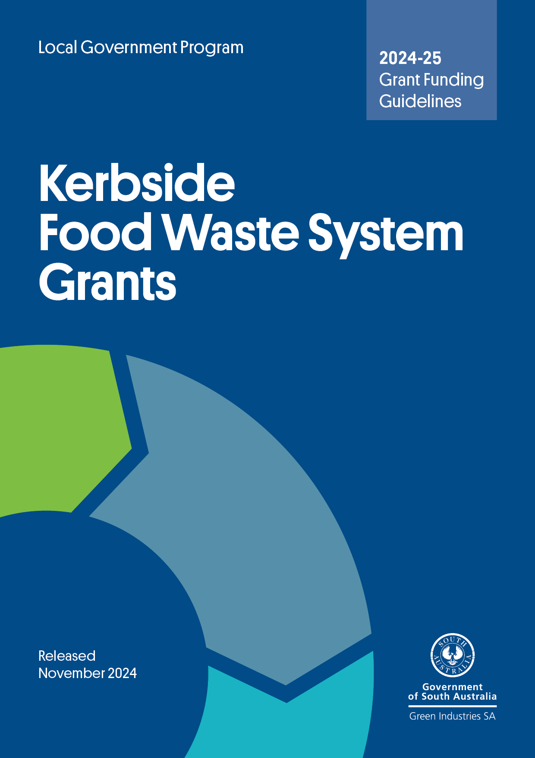

# 

**Contents**

Submitting your application 4

About Green Industries SA 5

South Australia’s Waste Strategy 5

South Australia’s Food Waste Strategy 5

Program overview 5

What do councils need to consider? 6

Grants to recycle food waste 8

Performance-based reporting, audits and financial support 8

What is the grant offer? 12

What are the conditions attached to the grant offer? 12

Conditions – further details 13

What is a ‘serviced tenement’? 13

Contractual arrangements 13

Privacy and commercial-in-confidence considerations 14

Application of grant monies 14

Frequently Asked Questions 14

Assessment process 15

Funding agreement 15

Frequently Asked Questions ………………………………………………………………...…16

# 

# Acknowledgment of Country

GISA acknowledges and respects the Traditional Custodians whose ancestral lands we live and work upon, and pays respect to their Elders past, present and emerging.

We acknowledge and respect their deep spiritual connections, and the relationship that Aboriginal and Torres Strait Islander people have to Country.

We extend our respect to all Aboriginal and Torres Strait Islander peoples and their nations in South Australia, and across Australia.

# Submitting your application

All applications must:

* use the form attached to these guidelines
* be submitted with a signed declaration
* be no more than 20 pages, and no more than 10MB (including attachments)
* be submitted electronically (Microsoft Word file) to [justin.lang@sa.gov.au](mailto:justin.lang@sa.gov.au) by **5 pm Friday 13 December 2024**, with the subject heading ‘Kerbside Food Waste System Grants – application’.

**Further information**

Contact Manager, Local Government and Infrastructure Justin Lang on (08) 8429 8416 or at [justin.lang@sa.gov.au](mailto:justin.lang@sa.gov.au).

# About Green Industries SA

Green Industries SA (GISA) is an enabler and driver of change, supporting the development of the circular economy through diverse collaborations which improve productivity, resilience, resource efficiency and the environment.

GISA works to transform how South Australians use and value resources, and the agency’s objectives under the *Green Industries SA Act 2004* are to:

* promote waste management practices that, as far as possible, eliminate waste or its consignment to landfill
* promote innovation and business activity in the waste management, resource recovery and green industry sectors, recognising these areas present valuable opportunities to contribute to the state’s economic growth.

[Learn more about GISA](https://www.greenindustries.sa.gov.au/).

# South Australia’s Waste Strategy

Initiatives funded through Kerbside Food Waste System Grants will support implementation of [*South Australia’s Waste Strategy 2020-2025*](http://www.greenindustries.sa.gov.au/resources/sa-waste-strategy-2020-2025). The strategy outlines actions that can contribute to a more circular economy in South Australia through:

* a clearly articulated policy and legislative framework that gives a solid platform for investment decisions and a stable and efficient market
* supporting innovation and commercialisation
* education, advocacy and awareness to support behaviour chance in the way waste and resources are managed
* applying the waste management hierarchy consistently with the principles of ecologically sustainable development.

# South Australia’s Food Waste Strategy

Kerbside Food Waste System Grants will also support implementation of [South Australia’s Food Waste Strategy – Valuing our Food Waste](https://www.greenindustries.sa.gov.au/resources/valuing-our-food-waste)*.* It’s the state’s first comprehensive strategy for reducing and preventing food waste being sent to landfill. It proposes actions to support households and businesses to reduce food waste sent to landfill and further opportunities for the organics recovery and processing sectors in South Australia.

Strategic actions to reduce and divert food waste are proposed across 3 program areas:

* Prevention and diversion of household generated food waste
* Commercial sector food waste generation and collection systems
* Attracting and supporting investment and markets

# Program overview

*Kerbside Food Waste System Grants* assist councils to implement sustainable and efficient food waste recycling systems for residents and small businesses that use council collected kerbside bins. It recognises that disposing food to landfill represents the loss of a potentially valuable resource and contributes to landfill greenhouse gas emissions.

Food waste still comprises about 3.3 kg of a typical household general waste bin presented for a weekly pickup in a metropolitan Adelaide kerbside collection. All metropolitan Adelaide councils have implemented green organics kerbside collections, accepting food waste and compostable materials alongside garden waste. If 70% of the households in metropolitan Adelaide participated and diverted food waste into the green bin, there is potential to remove an estimated 65,600 tonnes of food waste from landfill (equivalent to 6,000 truckloads) each year. Where this material is subsequently processed into high quality compost output products to meet Australian standards it can be reapplied to agricultural soils to grow more food.

In 2009–-2010 GISA, formerly Zero Waste SA, supported 10 South Australian councils in a household recycling food waste pilot which tested different systems and collection frequencies. The pilot involved the distribution of containers to residents in discrete geographic areas, and subsequent kerbside audits and market research to evaluate performance. The pilot’s report, [*Valuing our Food Waste*](https://www.greenindustries.sa.gov.au/resources/valuing-our-food-waste-sa-s-household-food-waste-recycling-pilot-2010)*,* highlights the diversion results achieved by each system and includes a summary of market research relating to the different systems.

The findings of the report have informed the structure of this program and implementation of best practice, high performing systems which maximise diversion from landfill and participation by householders. In addition, the program has evolved in recent years to adapt to the availability of compostable bags.

# What do councils need to consider?

### Container selection

Evidence shows that provision of kitchen containers to households greatly increases the diversion of food waste from landfill. When combined with educational material and awareness raising efforts, the containers act as a prompt located in the right place and time to encourage and enable effective and efficient food waste recycling practices.

Containers trialled in the pilot included a ventilated basket using a certified compostable liner and a fully enclosed, unlined caddy. Both were used as a kitchen bench-top receptacle for residents to place food waste generated through food storage, preparation and/or consumption. When the containers were full, residents placed the contents in their kerbside green organics bin for collection and processing.

The amount of food waste diverted will depend upon many factors. While performance of the lined ventilated basket and unlined caddy varied during the pilot, 3 times as much food waste was diverted with ventilated kitchen caddy and liner compared to the fully enclosed, unlined caddy.

Before applying for *Kerbside Food Waste System Grants*, councils should consider the outcomes of the 2009–10 food waste pilot (including market research findings and kerbside audit results) and the [*SA Better Practice Guide: Sustainable Kerbside Services*](https://www.greenindustries.sa.gov.au/resources/sa-better-practice-guide-sustainable-kerbside-services).

Applications should identify the type of container, costs necessary for their introduction, cost of container, assembly (if required), labelling/branding, distribution, and maintenance (if applicable).

### Lined containers

The pilot showed that the use of liners in association with a bench-top container increases the diversion of food waste. The use of certified compostable liners reduced the need for container cleaning, enabled easier transfer of the material to the green organics bin and reduced odours. These must be certified compostable to Australian Standard 4736-2006 and/or Australian Standard 5810-2010, made of cornstarch or equivalent and should be printed with an educational message about correct use.

The council’s role in distributing ongoing supply of liner bags to residents is a matter that should be determined by council. Councils will need to make some informed assumptions regarding the average number of bags required per week, per household to ensure sufficient initial supply and to maintain correct use with the system.

An initial supply of 75 liner bags provided with the ventilated basket for each participating household is expected to last each household for about 6 months based on the use of 2 to 3 bags a week. This amount is considered a reasonable guide, although it may vary depending on the number of people per household, food storage, preparation and food consumption, and disposal habits.

The September 2024 ban on single-use plastic barrier bags and uptake of certified compostable bags for fresh fruits, vegetables, nuts and confectionary will improve accessibility to suitable liners directly from supermarkets and therefore reduce the cost burden to council of replacement bags whilst encouraging the continued use of food waste systems by householders who may not readily visit a council office or library for replacement bags.

A pilot supported by the agency and coordinated by the City of Holdfast Bay in 2018–19 trialled the use of compostable bags in fresh food retail outlets as a means of removing barriers for residents in accessing liner bags for food waste systems. The pilot resulted in household food waste diversion doubling in the council area and the retail stores recognised the benefits of increased customers and ‘closing the loop’ in the circular economy by getting food scraps composted.

Grant funding towards liner bags will only be endorsed where containers are ventilated (requiring ongoing use of liner bags). Subject to the level of competition for grant funding, preference will be given to area-wide distribution of lined and ventilated containers, due to the higher diversion rates that residents achieve using such systems.

Financial support towards the rollout of unlined/non-ventilated food organics systems are a low priority as results have shown these systems do not achieve satisfactory diversion rates, primarily due to lower participation rates with these systems.

### Organics bins

Where required, funding for additional kerbside organics bins may be sought by regional councils only. Assessment of applications will consider competitive contract pricing, leveraging of funding, collection frequency, cost burden to council, and best use of available funds. GISA will also consider the size and colour of the organics bin.

# Grants to recycle food waste

*Kerbside Food Waste System Grants* provide support to councils to implement sustainable and efficient food waste recycling systems for households and small businesses. In doing so, the grants aim to assist with meeting targets and outcomes in [*South Australia’s Waste Strategy 2020-2025*](https://www.greenindustries.sa.gov.au/resources/sa-waste-strategy-2020-2025)and when processed to a high quality (including AS 4454 standards) and subsequently applied to agricultural, viticultural and horticultural settings, this will also achieve high level circular economy outcomes.

The level of grant funding provided will depend on the council’s approach towards introducing food waste recycling for incorporation into kerbside green organic bin collections. The key elements of the financial incentive are as follows:

* A contribution towards the cost of the introduction or expansion of a food waste system – up to 50% of cost of containers and education material included with containers at the time of distribution, to a maximum of $10 per tenement.
* A satisfactory performance report is due 12 months after the system has been rolled out. The report requires information on material processing site and end markets. Failure to provide the performance report may deem grantees ineligible for further GISA grants.
* GISA meeting the cost of a roll of 75 compostable liner bags delivered to all households in a geographic area using ventilated food waste systems.

# Performance-based reporting, audits and financial support

Where a council is provided a grant of $200,000 or more for the introduction or expansion of a food waste system, a kerbside audit must be undertaken within 12 months of the service being introduced, with costs met by council. For grants over $200,000 councils will also be required to submit a kerbside performance report, based on monthly load weight data, to GISA.

Applicants are to liaise with GISA regarding kerbside performance reporting, including the methodology for conducting kerbside waste and recycling audits.

Access to accurate, reliable and consistent data through the conduct of kerbside audits helps councils and GISA to plan future waste reduction strategies. Important reasons for undertaking a kerbside audit include:

* providing feedback to the community on their recycling efforts
* reviewing the performance of a new system
* reviewing an existing system prior to tendering for a new kerbside contract (or at a mid-term review)
* validating kerbside yields to GISA.

Councils receiving a grant under $200,000 are not required to carry out audits but are required to submit simplified reports.

### *Which Bin* branded education and information

Education is essential to raise and maintain awareness of the importance of food waste recycling. Education material must clearly define food and other organic material that can be diverted to the green organics bin and material that should not (contaminants).

It is expected that councils undertake communications throughout the year to advise householders of the availability of food waste containers and certified compostable liners. As a minimum, councils are expected to:

* provide printed education material along with the food waste container, using *Which Bin* branded materials
* place articles in newsletters and deliver other printed materials at least twice per annum, including where the food waste is processed and where it is being used
* promote food waste recycling in social media and online communications throughout the year, with a minimum of one post per month
* use awareness raising initiatives such as outdoor banners and signage for libraries or community centres.

The *Which Bin* branded range of market-tested and evidence-based behaviour change and awareness resources are managed by GISA. These can be customised with the council’s logo and include the mandatory educational brochure and other elements such as a bin lid heat stamp, banner, and flyer or rates notice insert. When councils are ready to start using *Which Bin* branded materials they should contact GISA’s Communications Adviser.

Examples from the suite of *Which Bin* branded education resources are included below.

**

**Information brochure for residents**

### Kerbside collection or backyard composting

*Kerbside Food Waste System Grants* are provided to encourage the diversion of household food organics from the residual waste stream. While a specifically designed kitchen-based food waste system is expected to achieve high participation and diversion rates, it will also involve some cost for the collection and processing the material.

Backyard composting has a place in encouraging increased retention of food waste and other vegetative material on-site without further collection or processing costs. Where the use of home-based composting is proposed, GISA may consider providing an incentive payment, if the approach is supported by appropriate education and information. The program will consider matching a council incentive for discounted home-based composting units (up to a maximum of $10 per tenement).

**Total system costs**

Applicants are encouraged to review the [SA Better Practice Guide: Sustainable Kerbside Services](https://www.greenindustries.sa.gov.au/resources/sa-better-practice-guide-sustainable-kerbside-services) which provides practical information and tools to SA councils on introducing the service model. The guide is supported by a [cost calculator](https://www.greenindustries.sa.gov.au/sustainable-kerbside-services) to help councils identify potential costs (or savings) of moving to the sustainable kerbside service model.

It does not replace a detailed business case or feasibility study, and councils should conduct appropriate due diligence before making any changes to kerbside services and contracts.

This report outlines assumptions on various aspects of introducing a food waste system, as well as forecasts on potential yields that could be achieved.

# What is the grant offer?

South Australian councils can apply for funding under the *Kerbside Food Waste System Grants* program on a ‘per serviced tenement’ basis.

GISA will provide up to 50%of the costs, up to a maximum of $10 per tenement, with council required to provide a satisfactory performance report within 12 months of the system rollout.

# What are the conditions attached to the grant offer?

* Councils must enter into a signed grant agreement with GISA in which the council commits to introducing or expanding a food waste system.
* Where kitchen-based food waste systems and kerbside organics bins are proposed, these must be used in conjunction with a kerbside green organics service at not less than a fortnightly basis.
* Support and maintain an approved service/approach with regular, ongoing education and communications using template communication material for a minimum period of 3 years.

# Conditions – further details

* A condition of funding for applicants receiving a grant with a total value of $200,000 or more is to provide a kerbside waste and recycling audit report to GISA within 12 months of the introduction of a kerbside food waste collection service/approach. Audits are to be undertaken using GISA’s preferred kerbside auditing methodology, including a representative sample of 100 bins for each kerbside stream. Audits are to be undertaken between 1 March and 31 May of the reporting year. For purposes of the diversion rate, calculations should not include hard refuse.
* A condition of funding is that organic material collected for processing/commercial composting will only be processed at an appropriately licensed EPA composting facility, managed according to EPA and other planning requirements, and that the material is processed into soil improvement products that meet Australian Standard 4454-2012 (where applicable) of which a significant portion is sold to third parties not affiliated with the collection company or processor.
* Community communication materials such as information brochures are to be checked by GISA before publication. GISA will assist councils to develop the educational material which must use template *Which Bin* branded educational materials for ongoing communications activity. These are expected to provide advice regarding accessing certified compostable liners in the future and how to use the system.
* Applicants should maintain the food organics system outlined in their application for at least 3 years.
* Councils failing to provide a performance report will be ineligible for further grants through GISA.

# What is a ‘serviced tenement’?

A serviced tenement is usually a household but may be a business if it is using the same kerbside waste and recycling service as surrounding households. The number of serviced tenements within a given council may be different for one component of the service when compared with another. For example, a council that provides an optional green organics service may have 26,000 serviced tenements for the residual waste service but only 18,000 serviced tenements for the green organic component. The incentive payment will be calculated and based on the serviced tenements actually receiving the prescribed service (in this example, 18,000 served tenements).

# Contractual arrangements

Successful councils will be required to sign a grant agreement with GISA before receiving funding. The agreement will be for an initial 3 years and will set out the performance standards that the council has agreed to maintain for that period.

# Privacy and commercial-in-confidence considerations

All applications will be treated as commercial-in-confidence. GISA reserves the right to include third party evaluations as part of the assessment process and has the ultimate discretion in relation to publicity for applications. Applicants shall not publicise their projects without the approval of GISA.

# Application of grant monies

Successful applicants will be required to apply grant funds to the rollout and continued support of kerbside food waste systems. While not a key feature of the grant assessment process, councils will be required to commit to applying grant funds in this way to ensure appropriate expenditure of waste levy-derived funds by GISA. This commitment forms part of the declaration (Section 11 of application form) by the council and will be a requirement of the grant agreement between the council and GISA.

# Frequently Asked Questions

**Q1. If I do not fully complete the relevant form, will it be assessed?**

A. No. **All** sections of the application form must be fully completed for it to be assessed.

**Q2. Will my application be accepted following the closure date?**

A. Further rounds will be called depending on interest and uptake. Late applications will be held over to future calls. Councils will be given the opportunity to update these in preparation for the next round.

**Q3. Can council seek funding for a redistribution of free bags?**

A. The incentive provides for “reinvigoration” of existing area-wide systems, as well as blanket distribution of new systems with ventilated containers. Funding may be sought for a roll of 75 bags when distributed with a ventilated container and educational material.

On 1 September 2024, bans on single-use plastic barrier bags for unpackaged fruit, vegetable, nuts and confectionery came into effect in South Australia. This has resulted in significant uptake of certified compostable bags in food retail outlets, improving accessibility to suitable liners across the community.

Outside of this grant program GISA will work with councils to develop educational materials and information for residents to promote availability of certified compostable bags for kitchen containers. To access this service, contact [greenindustries@sa.gov.au](mailto:greenindustries@sa.gov.au).

**Q4. What if council’s proposal cost is more than $10 per serviced tenement?**

A. The grant payment will provide 50% of the total costs, up to $10 per serviced tenement. GISA will meet 100% of the cost of the roll of 75 compostable bags in order to support maximum uptake of systems in 2025–26.

**Q5. Do I need to submit a council resolution as part of the application?**

A. No. However, before any payment is made by GISA details of a resolution and budget allocation will be required within 3 months to confirm that a grant application has been successful.

# Assessment process

Applications will be assessed and prioritised based on the following essential criteria.

**Essential criteria**

* The project requests no more than 50% funding contribution by GISA
* The project uses proven technology or technology that has been successfully demonstrated
* Council has resolved to implement or expand kerbside food organics collection systems, and has adequate funds set aside in the budget (if not, can it be confirmed when council will consider a report on food organics systems?)
* The project has a clear timetable for rollout
* *Which Bin* branded communications will be regular and ongoing, and sufficient funds have been allocated in the budget proposal for this activity
* Quotes have been provided for materials, according to council’s purchasing policy
* The application includes the expected diversion potential of the proposed system and information on the types of communication material that will be provided.

No project is guaranteed an allocation of funds by GISA. Funding through this program will be made entirely on a competitive basis, and GISA reserves the right to direct the funds to projects that are considered to be best value for money.

All applicants will be notified by the agency within two weeks of the submission date to confirm receipt of their proposals.

Applications will be reviewed by a panel comprising Green Industries SA personnel and external specialists. The panel will assess all eligible applications against the assessment criteria.

If required, additional written information may be requested from the applicant to assist with the assessment.

The panel will recommend projects to be funded and funding amounts to the Board of Green Industries SA for decision.

# Funding agreement

Successful applicants will be required to enter into a funding agreement with GISA. This agreement will set out the terms of the grant, conditions, payment schedules, project timing, key performance indicators, reporting requirements and other matters.

All required approvals, such as a council resolution, are to be provided within 3 months of the initial notification of the success of the application.

GISA must be acknowledged in all media and promotional activities relating to the project. The statement ‘*this project has been funded by Green Industries SA*’ or similar, would satisfy this requirement. Additional assistance will be provided to use the *Which Bin* brand. Copies of completed education material are to be provided to GISA.